Control and Data Acquisition of Unmanned Surface Vehicle

_______________________________

# A Research Project Presented to the

**Department of Electrical Engineering**

**College of Engineering**

**Mindanao State University - Iligan Institute of Technology**

**Iligan City**

**_______________________________**

**In Partial Fulfillment of**

**The Requirements for the Degree of**

**BACHELOR OF SCIENCE IN ELECTRICAL ENGINEERING**

**_______________________________**

**Kate Ira B. Augusto**

**Irish Mae G. Lariosa**

**Ian Benedict P. Pongcol**

**Prof. Carl Salaan Ph.D.**

**Adviser**

**2020**

**Table of Contents**

A Research Project Presented to the 0

CHAPTER 1 3

INTRODUCTION 3

1.1 Background of the Study 3

1.2 Problem Statement 4

1.3 Objectives of the Study 5

1.4 Significance of the Study 5

1.5 Scope and Limitations of the Study 6

1.6 Definition of Terms 6

1.7 Conceptual Framework 9

1.8 Theoretical Framework 10

1.8.1 Battery Monitoring 10

1.8.2 Motor Sizing 11

1.8.3 Rudder Servo Sizing 12

CHAPTER 2 13

REVIEW OF RELATED LITERATURE 13

2.1 Water Waste 13

2.2 Water Waste Collection 13

2.2.1 Alpha Boats 13

2.2.2 Trash Collection Skimmer Boat 14

2.3 Development of Unmanned Surface Vehicles 15

2.3.1 Water Quality Monitoring 16

2.3.2 WasteShark 16

2.3.3 Interceptor 18

2.4 Control System of Unmanned Surface Vehicles 19

2.5 Research Gaps 20

CHAPTER 3 22

METHODOLOGY 22

3.1 Firmware Design Process 23

3.2 Hardware Design Process 29

3.3 Software Design Process 32

CHAPTER 4 38

RESULTS AND DISCUSSION 38

CHAPTER 5 55

CONCLUSION AND RECOMMENDATIONS 55

REFERENCES 56

# CHAPTER 1

# INTRODUCTION

## Background of the Study

The Philippine Archipelago has approximately 7000 islands located in the Western Pacific. The Philippines, as a country surrounded by water, is one of the highest contributors of plastic waste in the marine environment. Data shows that the country contributes 0.28-0.75 million metric tons of plastic per year (Jambeck et al., 2015).

Plastics scattered throughout the ocean which subsequently resulted in different patches. Chemicals from plastics are spread into the atmosphere as well as the water that are damaging to humans. Chemicals from plastics like lead, cadmium, and mercury, in direct contact with humans, are dangerous which are associated with cancer, birth defects and immune system problems (Andrews, 2012).

Actions are taken to battle pollution in marine environments. Emerging technology for waste collection has been developed for the past few years. Alpha Boats, developed in New York have been used for trash and debris operations(AlphaBoats, n.d.). Trash skimmer boats, an invention by Stephen Walcyzk, works for collecting and disposing of solid waste materials in surface waters. These machines run with humans on board for operation and control (Walczyk, 2004).

With unmanned system technology, recent studies show successful machines with no humans on board. An example of the unmanned system is unmanned surface vehicles. Applications using this system are attained during the last few years of research and study; Water Quality Monitoring using USV (Demetillo & Taboada, 2019), WasteShark for solid waste collection (Swan, 2018), Interceptor for autonomous waste collection (Ocean CleanUp, 2019). Using an unmanned surface vehicle, an efficient method as an alternative for dangerous operation and collection of waste without onboard human presence can be achieved.

## Problem Statement

Situations in a dangerous environment often involve high-risk operation that needs human intervention. There is a need for a system to operate without a human onboard to ensure the welfare of the operator while running the machine. The researchers aim to develop a control system and a human-machine interface for an Unmanned Surface Vehicle that is capable of receiving and sending data information.

## Objectives of the Study

This research aims to develop a control system and a human-machine interface for an Unmanned Surface Vehicle for water waste collection. The study aims to:

1.) To implement a control system for USV

2.) To design and fabricate a controller shield for the control system

3.) To create a software application for monitoring and control

## Significance of the Study

The technology of unmanned systems takes the edge over manned systems in some areas. Unmanned systems execute in high-risk operations than manned vehicles with lower production and maintenance costs. With no humans on board, safety and loading capacity is considerably greater (Liu, Zhang, Yu, & Yuan, 2016).

Despite the proliferation of research on unmanned systems, the focus of researchers and companies for the past years is notably to unmanned aerial and ground vehicles than unmanned surface vehicles with about two-thirds of the earth’s surface is covered in water (Mancini, Frontoni, & Zingaretti, 2015). Development and demonstration of competent USVs have been observed recently (Manley, 2016).

As a country surrounded by water, the Philippines contributes significantly to water waste (Jambeck et al., 2015). Development of a system capable of receiving and sending data with no humans on board can aid in environmental missions such as the collection of water waste, bathymetry, and water monitoring.

## Scope and Limitations of the Study

This study focuses on implementing a control system for an unmanned surface vehicle for water waste collection. A controller shield for the control system will then be designed and fabricated. In addition, a human-machine interface will be created for data monitoring and control. The hardware components will be mounted on a (1.22m x 0.84m) catamaran hull. This will serve as a prototype of USV for water waste collection. The scope area of this study is on water bodies in the Philippines.

## Definition of Terms

A **catamaran** is a type of watercraft with two equally sized parallel hulls. Early catamarans were up to 21.3 meters long, paddled by many men and used for visits, wars, and exploration. The catamaran is derived from kattumaram, a Tamil term, meaning "logs joined together."

An **Electronic Speed Controller (ESC)** is a system that controls an electric motor's power from 0% to 100%. ESC can be categorized into two types: brushed and brushless. A **brushless motor** will be used in this study. Its speed can be varied by adjusting the timing of current pulses delivered to the motor's multiple windings.

The term **GPS** stands for "**Global Positioning System**", it is a satellite-based navigation system used for determining the ground position of any object. The United States government deployed 24 satellites into orbit intended for military use in the 1960s which after a few decades, made available for civilian use. GPS provides geolocation and time information 24/7, free of charge to anyone with a GPS receiver. To avoid weak GPS signals, a GPS receiver must be placed via direct line-of-sight to four or more GPS satellites.

A **Human-Machine Interface**, as the name suggests, is an interface that is capable of human-machine interaction. HMI is used in different industries like power plants, electronics, medical, military, and the like. In this study, it consists of firmware and software that allow signals from the machine to be translated into a human-readable visual representation of the system, in turn, provide required signals to the machine and vice versa. In this study **MATLAB GUI** (graphical user interface) is used to provide point-and-click control of the software application. This eliminates the need for the user to learn the language or commands in order to run the application.

An **Inertial Measurement Unit (IMU)** is a set of measurement tools used to describe a device's movement. It is a combination of sensors, specifically, accelerometers, gyroscopes, and magnetometers. **An accelerometer** is used to measure velocity and acceleration; **Gyroscope** measures the rotation and rotational rate; and the **Magnetometer** indicates the directional heading. The data obtained from these sensors can be used to derive the three special axes of a ship. **Roll** (Longitudinal/X-Axis) is an imaginary line that runs horizontally through the ship's length, through its center of gravity, and parallel to the waterline. A roll motion is a side-to-side tilting motion around this axis of the superstructure. **Pitch** (Transverse/Y-Axis) is an imaginary line that runs horizontally across the ship and through the center of gravity. A pitch motion is a ship's bow and stern up-down movement. Lastly, **Yaw** (Vertical/Z-Axis) is an imaginary line that runs vertically through the ship and its center of gravity. A yaw motion is a ship's bow and stern side-to-side movement.

A **Pulse width modulation (PWM)** is a method or a technique used in communication systems to generate an analog signal using a digital source. While digital signals have two outputs: on or off (1 or 0), analog signals, on the other hand, can be on, off and an infinite number of positions between 0 and 1.

**MATLAB** combines a desktop environment tuned for iterative analysis and process design with a programming language that directly expresses matrix and array of mathematics. It includes the Live Editor to create scripts in an executable notebook that combines code, output, and formatted text.

A **microcontroller** (MCU or Microcontroller Unit) is a compact Integrated Circuit (IC) dedicated to performing a specific application or task. Essentially, a microcontroller collects input, processes this information, and produces an action based on the collected information. Usually, microcontrollers operate at lower speeds, ranging from 1MHz to 200 MHz, and need to be designed to consume less power because they are embedded in other devices that may have higher power consumption in other areas.

A device that detects a physical stimulus and transmits a resulting impulse is called a **Sensor**. These physical stimuli could be temperature, moisture, a particular motion or the like. The output is generally a signal which is converted to a human-readable visual representation or transmitted to a network for further data processing.

## Conceptual Framework

In this research, the overall design of the system consists of two main parts: the computer and the USV. Both parts communicate with each other through wireless communication with each part consisting of different subgroups that are integrated together to perform the functions of remote-operated USV.

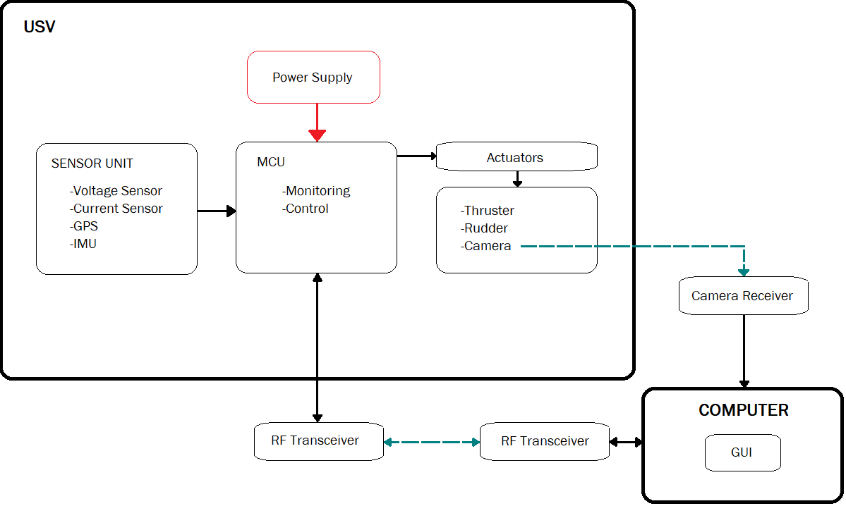

Figure 1.1 Conceptual Framework

## Theoretical Framework

##### Battery Monitoring

In order to monitor the battery, the State of Charge will be determined. Two methods: namely, Voltage Method and Coulomb Counting Method will be used to measure the battery's State of Charge. This will require reading data from voltage and current sensors.

The voltage method converts a reading of the battery voltage to the equivalent SOC value using the known discharge curve (voltage vs. SOC) of the battery (Murnane & Ghazel, 2017). To get the battery voltage, a voltage divider equation will be used

|  |  |  |
| --- | --- | --- |
|  | $$V_{batt}= \frac{R_{1}+R_{2}}{R_{1}} × V_{sense}$$ | (1) |

Where R1 is the Resistor 1, R2 is the Resistor 2 and Vbatt is the voltage level of the battery.

Data from voltage sensors will be used only for initialization purposes. Acquiring, state-of-charge by voltage is simple, but since temperature and cell materials affect the voltage, it can be inaccurate (Buchmann, 2019). That is why Coulomb counting will be used to update the new values of SOC.

|  |  |  |
| --- | --- | --- |
|  | $$time= \frac{1 min}{60 sec}×\frac{1 hr}{60 min}$$ | (1.2) |
|  | $${SoC}_{new}\%= {SoC}_{old}-\left(\frac{I ×time}{{Batt}_{AH}}\right)×100$$ | (1.3) |

##### Motor Sizing

For motor sizing of the USV, the relationship between motor angular velocity[rad/s], torque [Nm] and power [W] will be considered.

|  |  |  |
| --- | --- | --- |
|  | $$P_{m}= T_{m}×ω_{m}$$ | (1.4) |
|  | $$m_{v}∙ u= \sum{F_{drag}}+F_{thrust}$$ | (1.5) |
|  | $$\frac{P_{R}}{ω_{m}∙r_{m }∙χ}- \sum{F_{drag}}= m_{v}∙ u$$ | (1.6) |

Where ωm is the motor angular velocity, rm is the radius of action of the motor, Pr[W] is the necessary real power of the motor, $\sum{F_{drag} }$ is the sum of all the drag forces in the surge direction. χ [+]  is the performance coefﬁcient (Borreguero, Velasco, & Valente, 2018).

##### Rudder Servo Sizing

According to (Borreguero et al., 2018), rudder action will orient the USV which is executed by a servo motor. Concerning its sizing, the forces produced over the surface of the rudder in operation will be considered. With the distribution of pressures on its surface, the force exerted can be calculated:

|  |  |  |
| --- | --- | --- |
|  | $$F_{Rudder}= \int_{0}^{L}{ρg(L_{rudd}-Z)}∙bdz$$ | (1.7) |

Where g[m/s2] is gravitational acceleration, b[m] is the width, LRudd[m] is the rudder length, and z[m] the vertical that corresponds to the height in a cartesian coordinate system. Through the rudder action raction [m]radius, the torque Trudder exerted by the servo is expressed by:

|  |  |  |
| --- | --- | --- |
|  | $$T_{Rudder }= F_{Rudder}∙ r_{action}$$ | (1.8) |

# CHAPTER 2

# REVIEW OF RELATED LITERATURE

### Water Waste

Pollution finds ways into different marine environments. According to a study, about 5 trillion pieces weighing over 260, 000 tons of plastic spread throughout the oceans.  Accumulation of waste in the oceans results in potential damage to marine life and humans (Andrews, 2012).

### Water Waste Collection

With the alarming number concerning the amount of plastic produced and spread throughout the marine environment, proper waste management including waste collection is needed. In this section, machines developed for water waste collection are discussed.

#### Alpha Boats

Alpha Boats, a company in New York that produces vehicles for water management, has been a worldwide manufacturer of equipment for waste collection on water. One example is the marina cleaner shown in Figure 2.2.1.

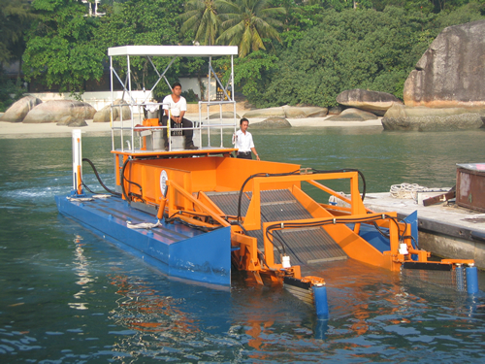

Figure 2.2.1 Marina Cleaner

The marina cleaner has a front pick-up conveyor able to collect large to small sizes of garbage. The design also has a short vertical clearance for movement under bridges. (AlphaBoats, n.d.)

#### Trash Collection Skimmer Boat

The trash collection skimmer boat invented by Stephen Walczyk works as an effective vehicle for the collection and discharge of floating debris. The machine is run by an operator in an elevated area above the boat hull. The operator can control the navigation of the vehicle. Furthermore, the operator can manage the movement of the conveyor (Walczyk, 2004). Figure 2.2.2 shows the drawing for the trash collection skimmer boat.

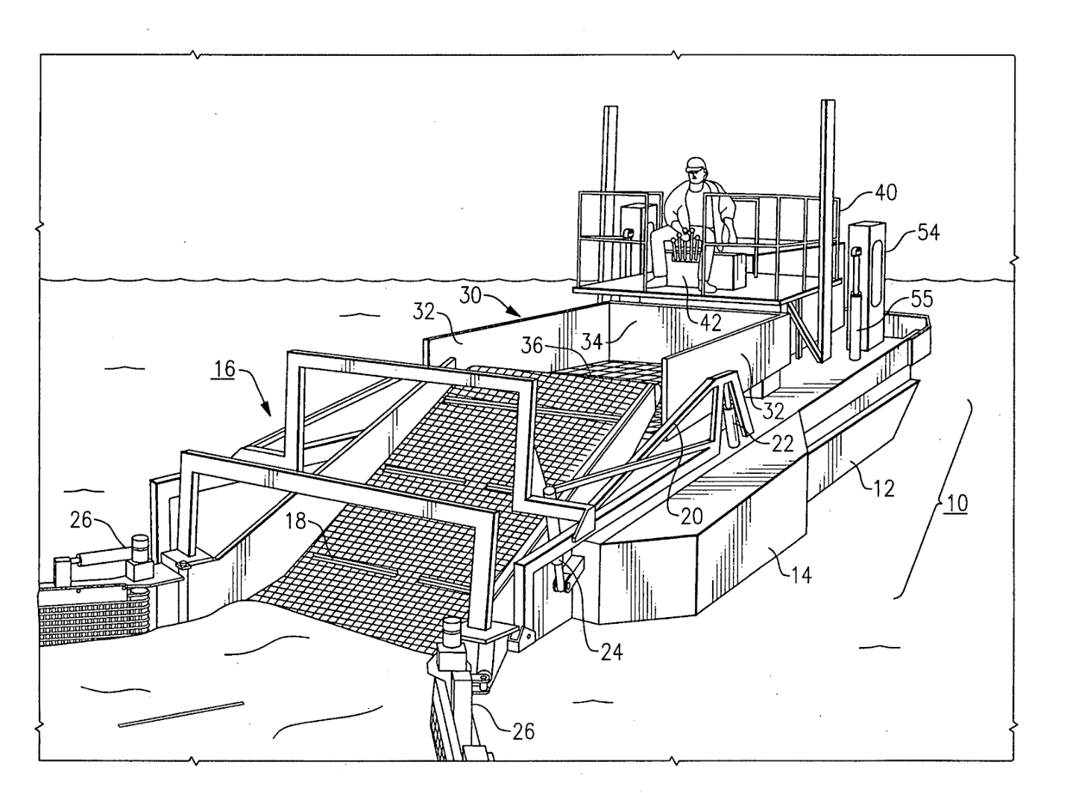

Figure 2.2.2 Trash Collection Skimmer Boat

Water waste collection can be managed and successfully be implemented with these manned machines. However, with the progress of technology over time, improvement of manned vehicles can be observed through the development of unmanned systems.

### Development of Unmanned Surface Vehicles

Water waste collection can be managed and successfully be implemented with these manned machines. However, with the progress of technology over time, improvement of manned vehicles can be observed through the development of unmanned systems.

###### Water Quality Monitoring

The need for real-time data acquisition for water quality monitoring is increasing because of its efficiency, and accuracy. The researcher created a low-cost unmanned surface vehicle of water quality monitoring for small aquatic areas.  The USV has a water quality sensor as its primary component. It was designed to operate autonomously or remotely operated depending on the location of the area. Water temperature and pH were measured by the sensors that were connected to the Arduino Mega 2560 Microcontroller. The real-time data were sent to the ground station using the Xbee transceiver module for short-distance transmission and GSM/GPRS transceiver for long-distance transmission. The received real-time data were then logged to the designed USV data logger developed using Visual Studio. The USV was tested to conduct a water quality testing mission with a pre-inputted route and the USV performed well in data transmission and navigation. With the successful implementation of the USV,  the system can enhance information dissemination on the quality status of the water (Demetillo & Taboada, 2019).

###### WasteShark

A drone technology company from the Netherlands, RanMarine Technology, developed an aquadrone that “eats” unwanted plastic, alien/pest flora, and other litters from the water surface. This aquadrone is called the WasteShark™. Shaped like a shark with an open wide mouth, it measures 1.5 meters by 1.1 meters, produces zero greenhouse emissions and can carry up to 159.6kg of trash (Swan, 2018). It was designed for use especially in harbors and ports.

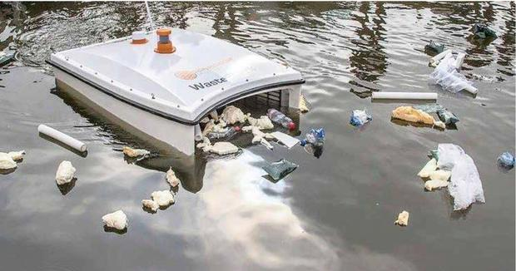

The WasteShark is currently operating in Netherlands, Dubai and some parts in South Africa. It is available in two (2) models, a remote-controlled model costs around $17,000 and the autonomous model cost just under $23,000 (Swan, 2018).

Aside from its expensive price, its size is also of concern. An NYU Abu Dhabi professor of biology, John Burt, said that "In terms of the units that are currently being deployed, I think they're relatively small and going to have a minor impact. But if it's proof of concept for the principle, then potentially it could be used on a larger scale,".

###### Interceptor

An environmental organization founded by Boyan Slat based in Netherland, the Ocean Cleanup introduced an autonomous system for river plastic waste. It is a pioneering scalable invention that prohibits waste from rivers to enter the oceans, hence being called the *Interceptor* (Ocean CleanUp, 2019).

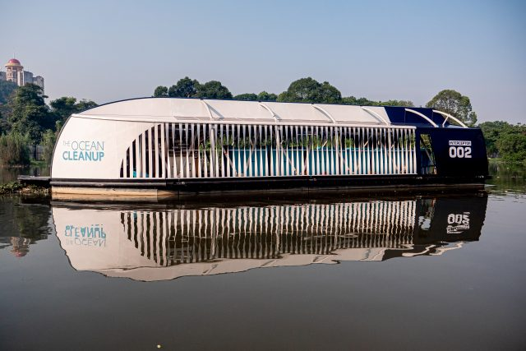

Figure 2.3.1 The Interceptor in a river in Malaysia

The machine, with the size of 8m x 24m x 5m, has the capacity of 50 cubic meters, having the conveyor belt extraction rate of 24kg/s can pull out autonomously 50,000 kilograms of waste per day. It is powered by solar energy with a capacity of 5.6 kWp and with a battery capacity of 20 kWh Li-on.

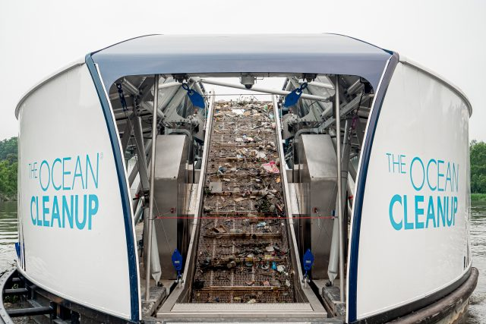

Figure 2.3.2 Inside the Interceptor

### Control System of Unmanned Surface Vehicles

Developed a modular unmanned Surface vehicle for research and educational purposes. They presented an integrated multi-level control design consists of Control and Communication (C&C) Level, Navigation Level, and Drive Level so that students can modify and develop their own algorithm one at a time. The components connected to (C&C) Level were the radio modem, GPS module, and the weather sensors, while the Navigation Level had an IMU connected to it and lastly the Drive Level consists of ESC(Electronic Speed Controller), Servos, water pump, and temperature sensors. The multi-level control design communicates via I2C(Inter-Integrated Circuits) protocol. The proposed USV can operate autonomously or can be controlled remotely over wireless radio-link. Each component can be modified according to a specific application and environmental conditions making it a highly modular design (Vasilj, Stancic, Grujic, & Music, 2017).

Researchers presented a study on the controller design of the surface cleaning robot. The robot’s propulsion control system was designed based on the principle of PWM  speed control (Yuyi, Yu, Huanxin, Yunjia, & Liang, 2013). A stepper motor was installed for the garbage collection and 2 DC motors w, 1 for each hull for the propulsion system. It will be powered by a battery and solar photovoltaic panels. The robot can perform forward, backward, left, and right maneuvers according to the command sent by a host computer. The robot can perform cleaning operation activities and can achieve good control effects.

### Research Gaps

For the manned vehicles, it is to be noted that a human presence on board is required for the system to operate thus labor cost and safety of the operator are considered.The development of these vehicles requires larger dimensions that restricts the mobility of the machine in small areas and results in expensive production and maintenance cost.

Unmanned Surface Vehicles are used in different areas of research. The vehicle developed by Demetillo and Taboada (2019) is used for water monitoring and data acquisition using water quality sensors. Further projects like the wasteShark and the Interceptor are developed for trash collection however the machines have high-priced production costs. Although WasteShark has the ability to maneuver in small areas, due to its size, it can only collect a few tons of trash. Compared to the WasteShark, the interceptor has the capability to collect a few hundred tons of trash per day however with its size it is only suitable to be operated in large water areas.

# CHAPTER 3

# METHODOLOGY

This chapter details the design and methods that will be used to meet the objectives set for this study. Content is arranged into four (4) sections: the first section discusses the firmware design process; the second section explains the hardware design process; the third section shows the software design process; the fourth section tackles the testing and evaluation process. Algorithms that are hitherto unspecified will be defined as they are introduced and discussed in this chapter.

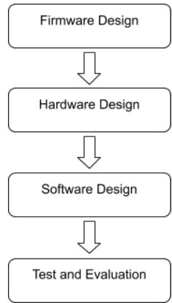

Figure 3.1 Project Design Flow

1. Firmware Design Process

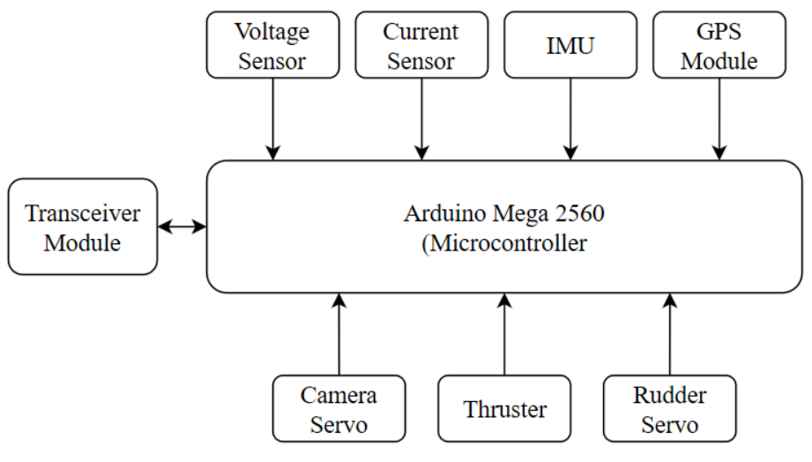

Figure 3.2 Firmware Design

1. Battery Monitoring

Voltage Sensor module and Current Sensor module was used to measure the voltage and the current that flows out from the battery. The output of the modules was connected to the analog pins of the microcontroller. The analog readings were used to calculate the actual voltage and current. The State of Charge of the battery was obtained by approximation. The data was grouped in the VSCS tag in a format of “$VSCS,Voltage,Current \n”

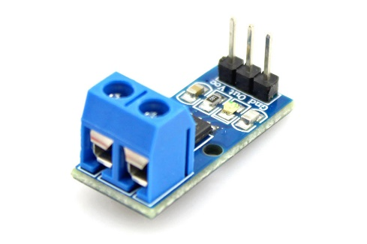

**Figure 3.3 Current Sensor**

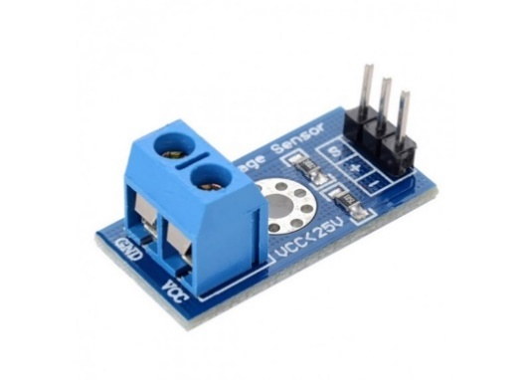

**Figure 3.4 Voltage Sensor**

1. Maneuvering and Camera Movement

The drive module of the USV consists of a single 3650 4300KV Motor 60A Brushless Motor controlled by ESC (Electronic Speed Controller) based on PWM(Pulse Width Modulation) principle for the thruster. Dynamixel AX-12 Servo was used for the waste collection conveyor. For rudder movements, the rudder was attached to a servo motor that can move to a certain degrees from left to right. The data pins of the following motors were connected to digital/PWM pins 8 and 9 of the microcontroller.Meanwhile, the data pin of Dynamixel AX-12 Servo was connected to the hardware serial 3 TX pin of the microcontroller. The motors were programmed to respond accordingly every time the user sends a command to tilt the camera, to maneuver the USV and to begin the waste collection operation.

There’s an added feature that sends a string to the ground station when a command was successfully executed by the microcontroller for confirmation. It serves as a feedback when a command is sent.

Table 3.1 below shows the controls of microcontroller. When a char is received, the following command will be executed, and its feedback message will be sent back to the ground station confirming that the command was executed successfully by microcontroller.

|  |  |  |
| --- | --- | --- |
| char(received) | Command | Feedback |
| W | Forward Propeller | “FORWARD” |
| S | Stop Propeller | “STOP” |
| A | Left Rudder | “TURN LEFTl” |
| D | Right Rudder | “TURN RIGHT” |
| Q | Center Rudder | “CENTER” |
| C | Start Conveyor | “CONVEYOR ONl” |
| V | Stop Conveyor | “CONVEYOR OFFl” |
| 0 | Speed 0 | “SPEED SET TO 0” |
| 1 | Speed 1 | “SPEED SET TO 1” |
| 2 | Speed 2 | “SPEED SET TO 2” |
| 3 | Speed 3 | “SPEED SET TO 3” |
| 4 | Speed 4 | “SPEED SET TO 4” |

**Table 3.1 Microcontroller Controls**

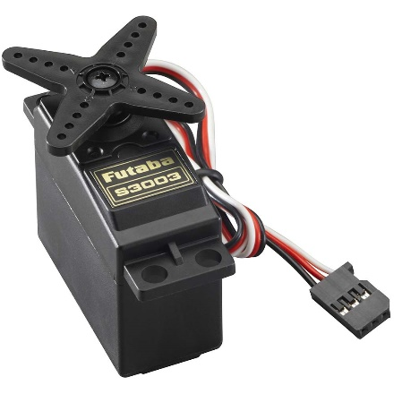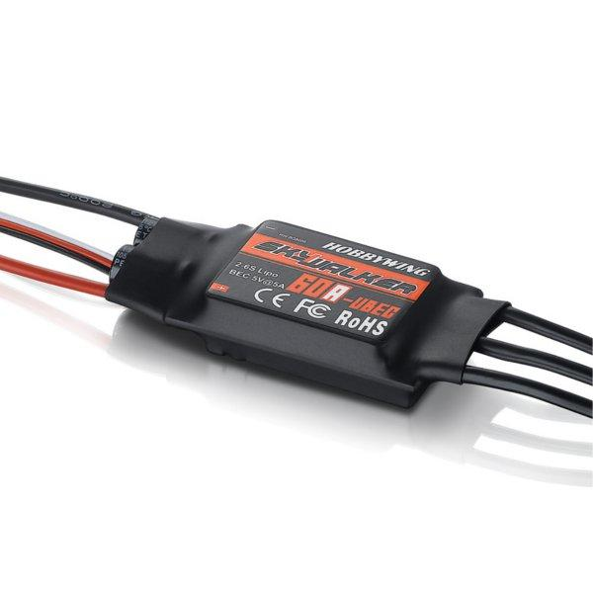

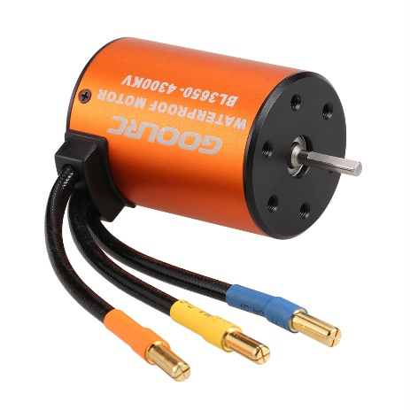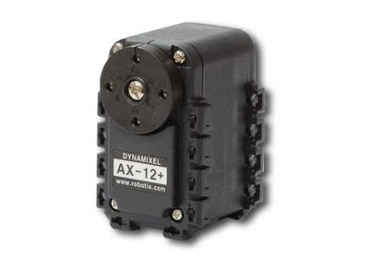

**Figure 3.5 Motors**

1. Global Positioning System (GPS) Module

The GPS module was powered by the 3.3v power supply of the microcontroller because it will be damaged in the 5v power supply. The Tx/Rx pins of the GPS module were connected to the digital pins 10 and 11 with the help of Software Serial protocol. Latitudes and longitudes coordinates were obtained by the module as well as the speed of the boat in NMEA format. “TinyGPS++” library was used to parse the NMEA data format. The data was tagged inside the GPS tag in a format of “$GPS,Latitude,Longitude,Speed \n” and was sent serially to the ground station with a sample rate of 1hz. GY-NEO6MV2 NEO-6M GPS Module was used in this project.

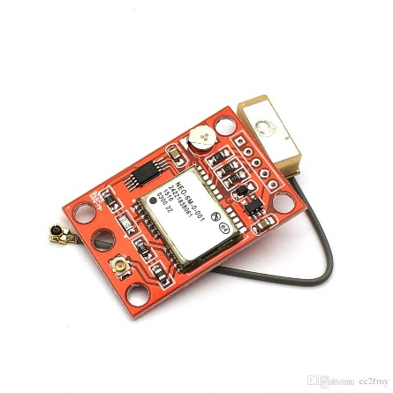

Figure 3.6 GPS Module

1. Inertial Measurement Unit (IMU)

The 9-DOF Accelerometer, 3-axis accelerometer, gyroscope, and a magnetometer was used to estimate the orientation, position, and acceleration of the USV. The acceleration and angular velocity was obtained from the IMU module through the inter-integrated circuit (I2C) communication. The Euler angles, roll, pitch, and yaw was computed in and was sent through serial communication. The data was grouped in IMU tag in a format of “$IMU, Roll, Pitch, Yaw \n”. MPU-9250 was used for this project.

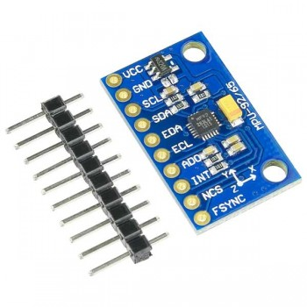

Figure 3.7 IMU Module

1. Transceiver Module

For wireless communication, a transceiver module was connected to the hardware serial 3 of the MCU and the other one for the ground station using a USB-TTL Serial Converter. Command signal was sent from the ground station and the sensor data from the USV was sent to the ground station through this transceiver module. HC12 RF Transceiver was used for this project.

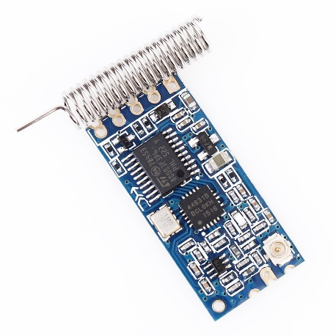

**Figure 3.8 Transciever Module**

1. Hardware Design Process

The catamaran watercraft was modeled and produced by Engr. Manuel Chad Agurob, Engr. Muhammad-Ali Dimapalao, and Engr. Jeff Riveral Gorre, students of doctor of engineering program in MSU-IIT.  The circuit of the control system was placed on top of the hull of the watercraft. Figure 3.2.1 shows the block diagram of the circuit of the control system. The figure shows an overview of the control system used in the surface vehicle.

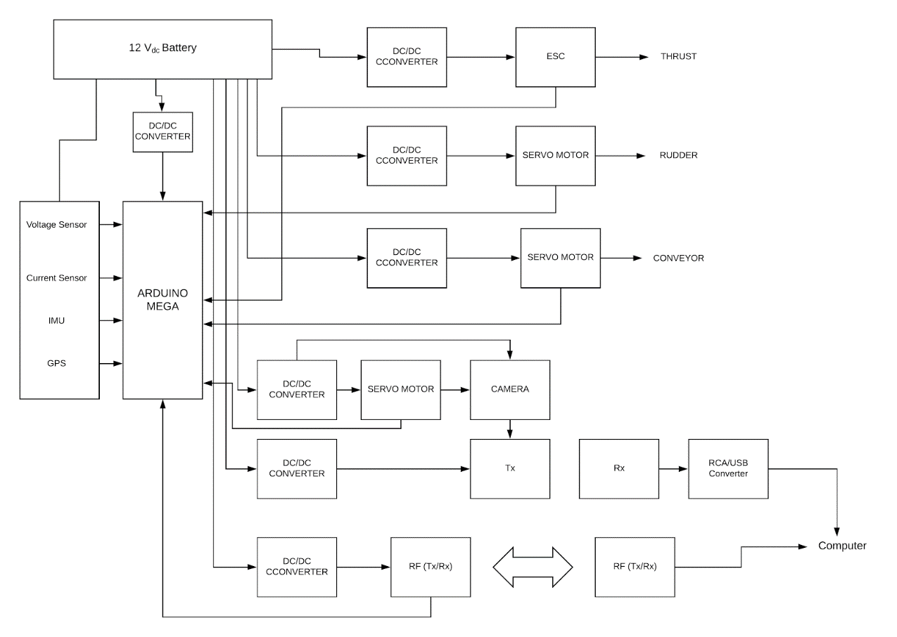

Figure 3.3 Block Diagram of the Control System

1. Circuit Design

For the design of the controller shield, an electronic design automation tool can be used. EasyEDA is a software that enables the user to create a schematic design, circuit simulation, and PCB layout. It can also be accessed online and save it to cloud. The circuits to be used for the control system was connected in a single controller shield.

The software was used for the design of the circuit controller shield and PCB layout. The designed PCB layout was fabricated.

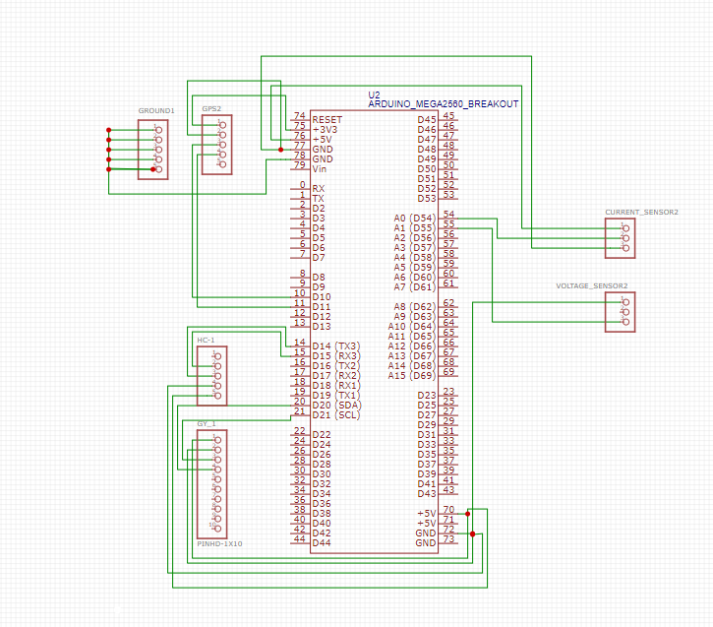

**Figure 3.9 Schematic Design**

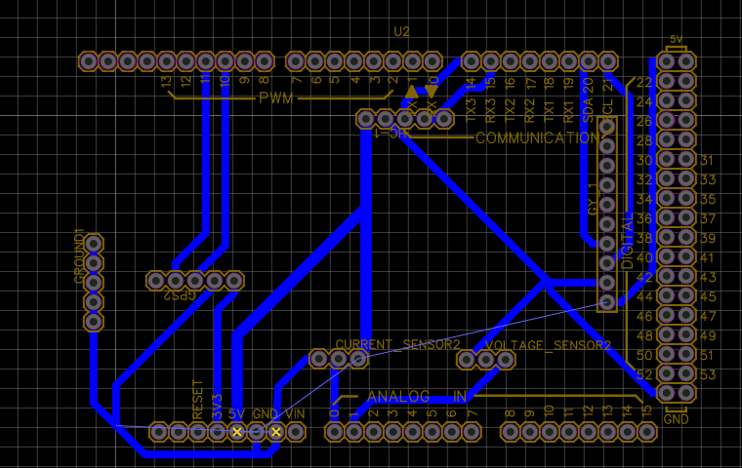

**Figure 3.10 PCB Layout**

1. Power Regulation in Motors

With only one source of power and different power requirements, the motor is subjected to the use of converters. To regulate the power and control the voltages of the motors a dc-dc buck converter was used .

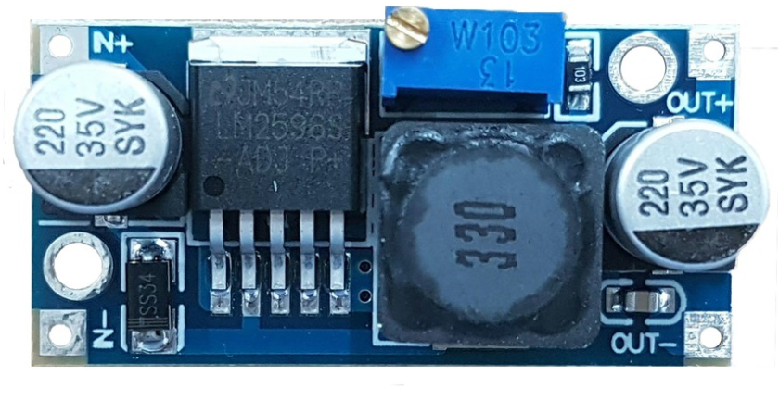

Figure 3. 11 DC-DC Buck Converter

1. Software Design Process

In order to make the USV easy to operate, the use of a graphical user interface was of great assistance. The existence of controls such as menus, toolbars, buttons, and sliders in MATLAB GUI makes it convenient for a wide range of applications. In this project, the MATLAB GUI was used to implement the software application for monitoring and control.

1. Graphical User Interface

The graphical user interface design consisted of user control panels, video frame and monitoring panels. It had additional features: namely battery status and time. A special button was provided to allow the user to capture images from the video frame. The captured images were automatically saved into a designated file.

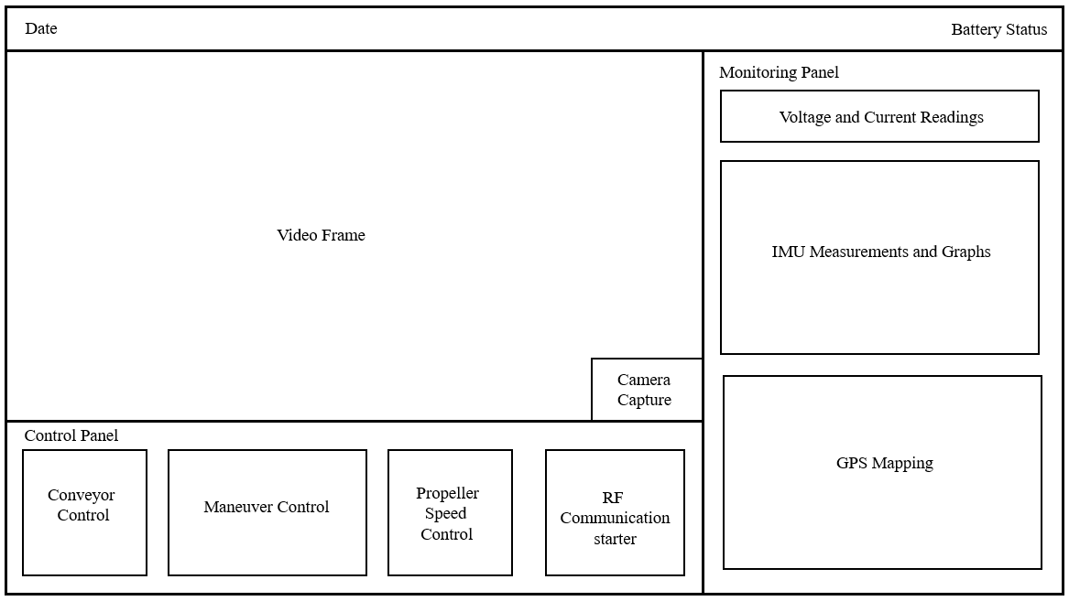

Figure 3.3.1 Human-Machine Interface

1. Serial Port Communication

To receive and transmit data, the software application utilized the ‘serial’ function to create a serial port object with the specified property name and property value. The baud rate was set to 9600, similar to the USV. The COM port is selected by the use of the ‘instrhwinfo('serial')’ function which provided the available serial hardware. To start obtaining and editing data, the function ‘fopen’ is used.

Once the communication between the USV and graphical user interface was established, receiving and transmitting data were done using the “fscanf” and “fprintf” functions, respectively. The ‘fscanf’ function reads the data from the open text file. The ‘fprintf’ function returns the number that ‘fprintf’ writes to the open text file, using any of the input arguments in the preceding syntaxes. Additionally, in order to sort the string of data received by the software, the ‘strtok’ function was used. This function parses string from left to right, using the specified character, in this case, ‘,’ as delimiters, and returns part of the text in token. Lastly, the data received was monitored and set to zeros (0) when it reached the maximum allowed rows and columns to avoid cluster of data.

1. Video Streaming and capture

In accessing the wireless camera from the USV, the ‘imaqtool’ command was utilized. The command showed all the available video input devices attached to the computer and its properties. This allowed the connection of the right video input. The video was then shown in an axis in the user interface.

A button on the bottom-right corner of the video frame was provided. This button served to capture images from the video frame by the use of ‘getframe’ function. The images are then saved in a specified file in the computer with the name of the time format ‘yyyy-mm-ddTHHMMSSZ’. It was necessary to name the images this way, since every name should be unique for each image to avoid overwriting.

1. User Controls (Keyboard Shortcut for Control)

The graphical user interface consisted of buttons that allowed the user to control the USV. The set of buttons were either push buttons, toggle buttons or slider, depending on which is more convenient. Each of these buttons had a specific function and pressing it transmitted a specific character to the USV through wireless serial communication to perform its corresponding function. In addition, shortcut keys to these buttons were provided to enhance accessibility, shown in table 3.3.1.

3.3.4.1 Maneuver Control

For maneuvering, push buttons allowed the forward, stop, left, right and center movement of the USV. Pressing these buttons sent data to the firmware to perform the specific maneuver command. Sending a ‘w’ moved the USV forward, ‘a’ turned it to the left, ‘d’ turned it to the right, and ‘s’ stopped it.

3.3.4.2 Conveyor Control

A toggle button was used to control the conveyor of the USV, since it was either on or off. Pressing this toggle button sent data to the firmware to perform the corresponding command. Sending a ‘C’ turned the conveyor on, while sending a ‘V turned the conveyor off.

3.3.4.3 Propeller Speed Control

A slider is used to control the propeller’s speed. The length of the slider is divided into 9 corresponding speed. From bottom to top of the slider, the corresponding speed is 0 to 9, respectively.

3.3.4.4Keyboard Control Shortcuts

By the use of ‘keypressfcn’ function of MATLAB, use of shortcut keys were made possible. This made it more convenient to control the USV. Edit text was provided in the control panel to input the specific letters and numbers assigned for control.

|  |  |  |
| --- | --- | --- |
| Data Sent | Shortcut Keys | Action |
| W | w | Move USV forward |
| S | s | Stop USV |
| A | a | Turn USV to left |
| D | d | Turn USV to right |
| Q | q | Turn USV to center |
| C | c | Turn conveyor on |
| V | v | Turn conveyor off |
| 0 | 0 | Set propeller speed to 0 |
| 1 | 1 | Set propeller speed to 1 |
| 2 | 2 | Set propeller speed to 2 |
| 3 | 3 | Set propeller speed to 3 |
| 4 | 4 | Set propeller speed to 4 |
| 5 | 5 | Set propeller speed to 5 |
| 6 | 6 | Set propeller speed to 6 |
| 7 | 7 | Set propeller speed to 7 |
| 8 | 8 | Set propeller speed to 8 |
| 9 | 9 | Set propeller speed to 9 |

Table 3.3.1 Control Commands

1. Sensor Data Interpretation

Through wireless communication, strings of data were sent from the USV to the ground station by the firmware. These strings of data were decoded by the software. As mentioned in section 3.3.2, these strings were parsed and then tokenized. The tokenized data was then represented through textual or graphical representation.

3.3.5.1 GPS Mapping

-Work in progress-

3.3.5.2 Battery Monitoring

-Work in progress-

3.3.5.3 IMU

-Work in progress-

In order to correctly evaluate the performance of the USV system, the sensors and control units underwent evaluation tests. In these tests, at least three (3) attributes was measured: namely, sensitivity, accuracy, and precision.

For the sensors, its sensitivity or the ability of the sensors to transmit changes in measurements in the quickest amount of time was tested. The ability of the sensors to give a true measurement, its accuracy, and its ability to give consistent results, its precision, are good measures to ensure valid data acquisition. The data provided by the sensors was compared with actual data measured from reliable devices. Then, the mean percentage of errors was calculated.

For the control units, its responsiveness to the command of the user, the ability to perform according to the task and give consistent results was tested.

# CHAPTER 4

# RESULTS AND DISCUSSION

Due to unfortunate events caused by the threat of COVID-19, the researchers were unable to complete yet the needed tests and data collection of the unmanned surface vehicle. The researchers, however, for the past few months, worked on their objectives. This chapter is an update of the progress results made by the researchers for the past few months.

1. Hardware
2. Fabrication Controller Shield

The design of the PCB was achieved using the software EasyEDA.The fabrication of the PCB layout was done in the RF Laboratory of the Department of Electrical Engineering Technology located in the 2nd Floor building of the College of Engineering and Technology. Figure 4 shows the fabricated controller shield.

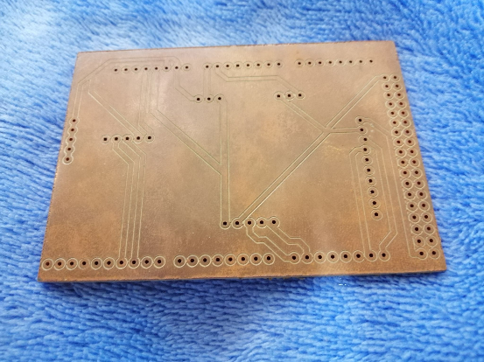

Figure 4. 1 Printed Circuit Board

Continuity test was conducted for the checking of short circuit in the board. Unforseen events led the researchers to halt the operation on soldering the parts. Figure 4.2 shows the set-up for the soldering of the components.

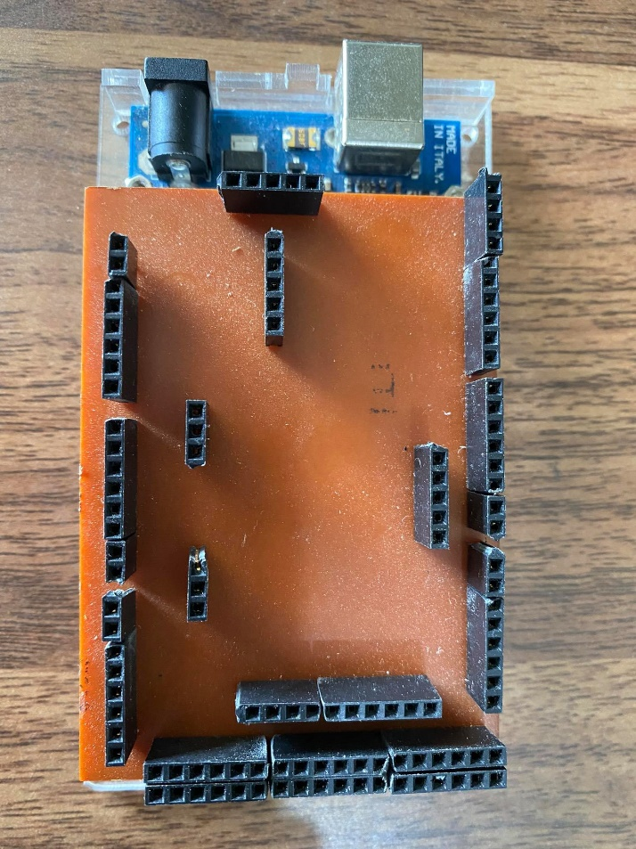

Figure 4. 2 Printed Circuit Board with Female Header

A continuity test was conducted for the checking of short circuits in the board. The researchers are successful in soldering the female header pins on the board for the parts to be inserted.  Figure 4.2 shows female header pins on the printed circuit board.

1. Power Regulation in Motors

The power supply and components used in the study with the corresponding power requirements are shown in the table below. Note that the data presented are based on the datasheet of the components.

|  |  |  |  |
| --- | --- | --- | --- |
| POWER SUPPLY | VOLTAGE | CURRENT | POWER |
| Lithium Polymer Battery | 12.6V | 8A( Max continuous discharge current)  30A(Peak Discharge Current) | 28W |
| Lead Acid Battery | 12V | 8 | 84W |
| COMPONENTS | VOLTAGE | CURRENT | POWER |
| ARDUINO MEGA | 7V-12V | 20mA-50mA | 0.084W-0.6W |
| GPS SENSOR | 3V-5V | 10mA | 0.03W-0.05W |
| IMU SENSOR | 3V-5V | 3.7mA | 0.0111W |
| CONVEYOR MOTOR | 9V-12V | 50mA-90mA | 0.45W-1.08W |
| RUDDER MOTOR | 4.8V-7.2V | 100mA | 0.48W-0.72W |
| PROPELLER MOTOR | <12V | 75A | 900W |
| WIRELESS TRANSCEIVER | 3.2V-5.5V | 16mA | 0.0512W-0.088W |
| CAMERA | 12V | 260mA | 3.12W |
| VOLTAGE SENSOR | 0V-25V |  |  |
| CURRENT SENSOR | 5V |  |  |

1. Catamaran Set-up

The catamaran was designed and produced by professionals and was used by the researchers to test the control and monitoring system. The figure below shows the overall look of the catamaran attached with a platform and a conveyor belt for the collection of trash.

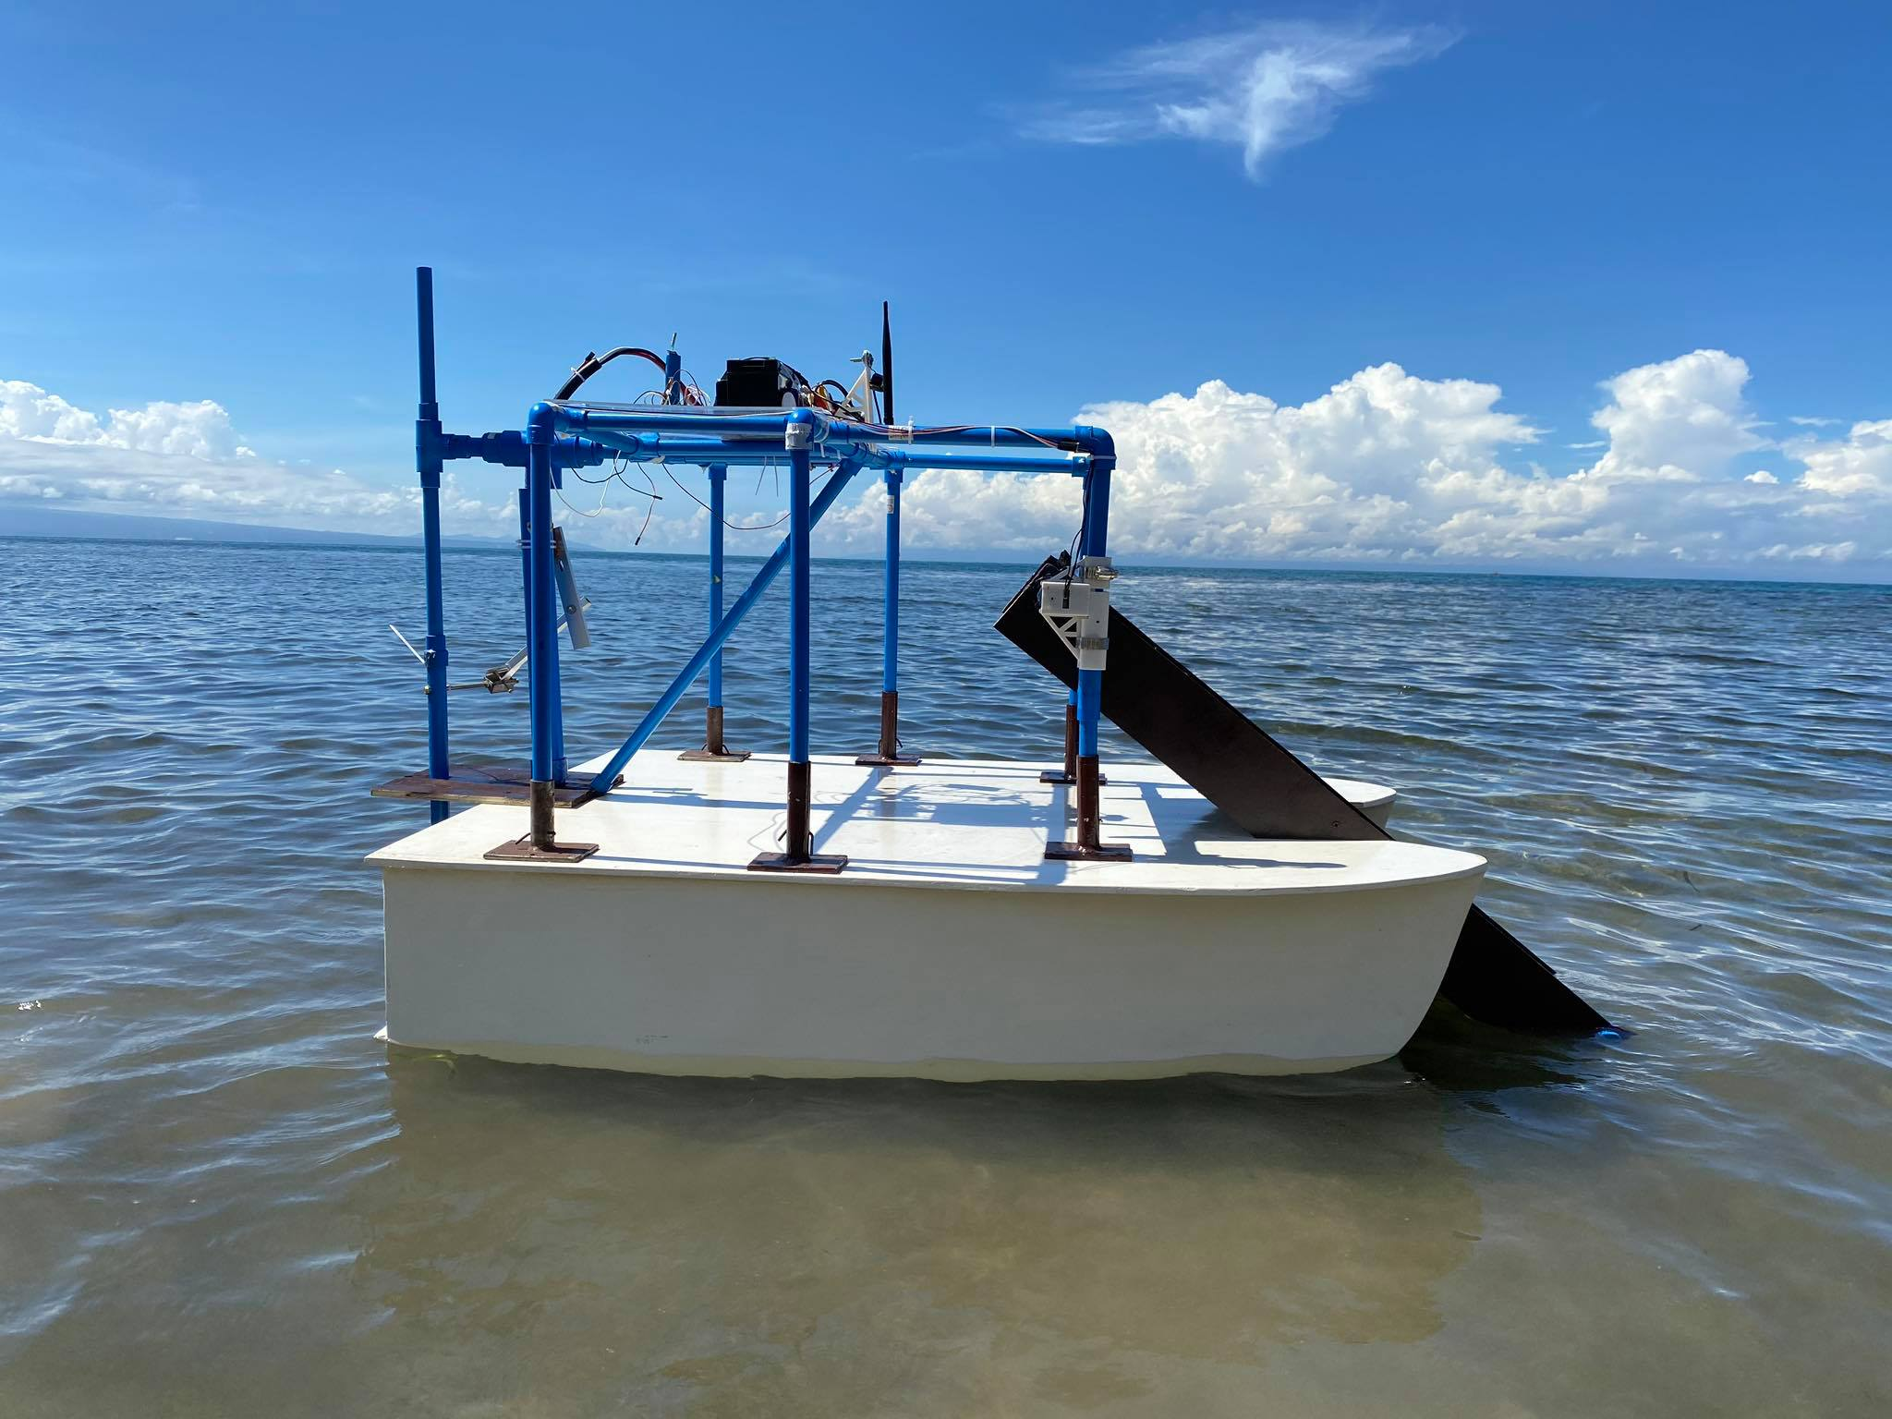

Figure 4.3 Catamaran

The researchers with the help of the professionals assembled the boat along with its motors. A platform was built on top of the catamaran to hold the control and monitoring components.

To avoid exposure to water,  the components are organized inside a container then placed on top of the platform.  Inside the container are the sensors, LiPo battery, lead acid battery, Arduino Mega, DC-DC converters.

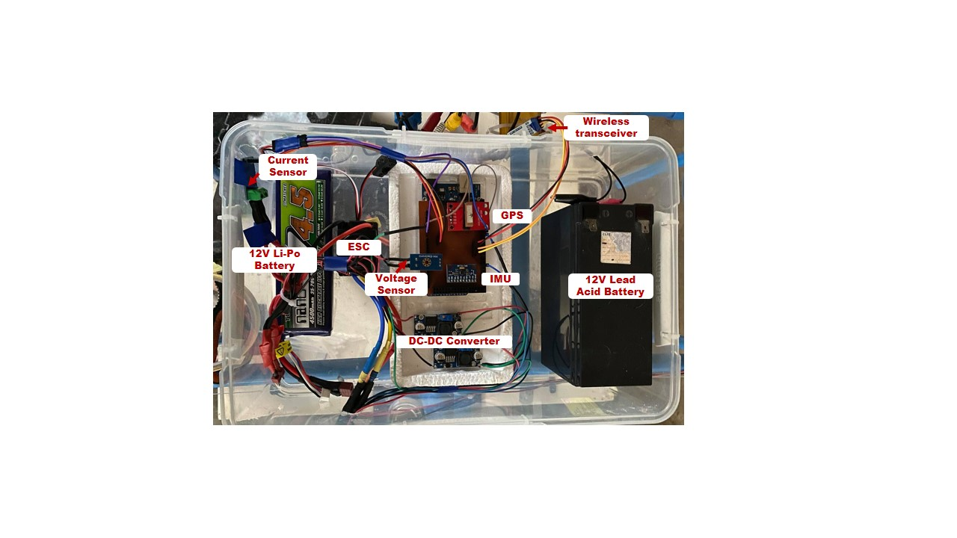 Figure 4.3 Components inside the container

Three motors were used in the system that served as the propeller, rudder and conveyor attached with a belt. With the three motors, the catamaran is able to move, change direction and collect tangible trash.

The servo motor serves as the rudder of the boat that allows the change of direction. Using a rudder mechanism that lets a piece of wood be responsible for changing the direction of the boat from left to right with an angle of 30 degrees on both sides.

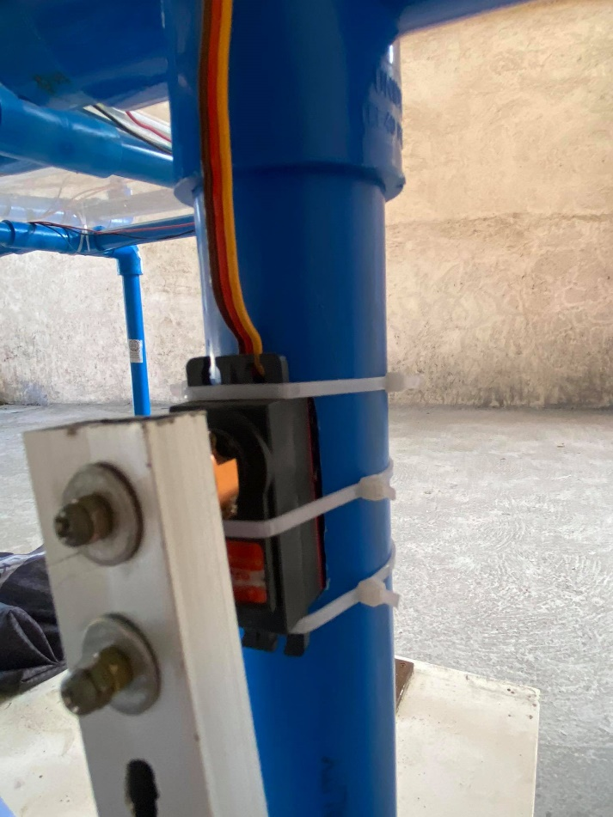

Figure 4.4 Servo motor used as rudder

A DYNAMIXEL AX-12 servo motor was used to rotate the conveyor continuously. The motor was used due to its high torque capability.

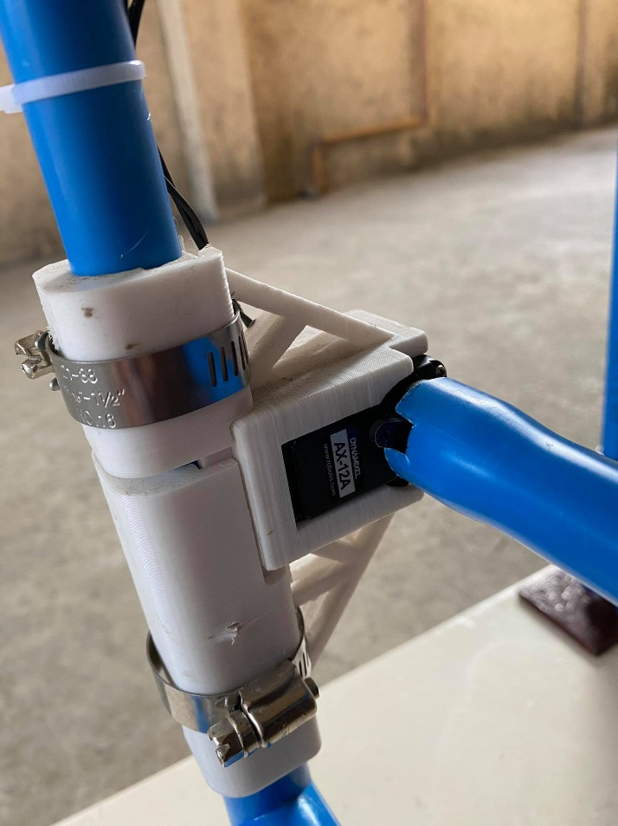

Figure 4.5 DYNAMIXEL AX-12 servo motor

A brushless motor was used as a propeller of the boat. It is attached to an electric speed controller then connected to the battery. The user can control the speed of the propeller using the user interface.

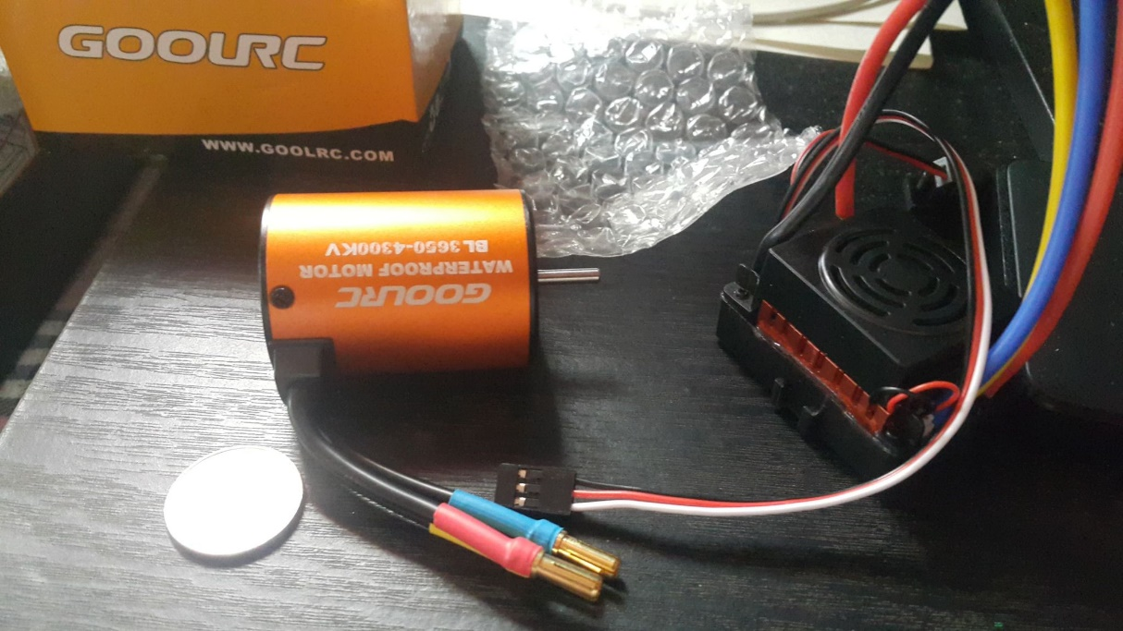

Figure 4.6 Brushless Motor

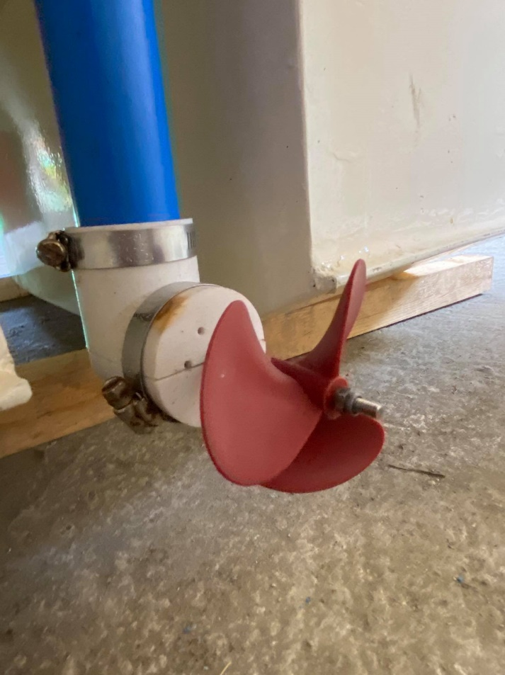

Figure 4.6 Brushless motor attached to the propeller

A camera was attached on top of the platform to monitor the collection of trash on the conveyor belt. It is powered by the 12V lead acid battery.

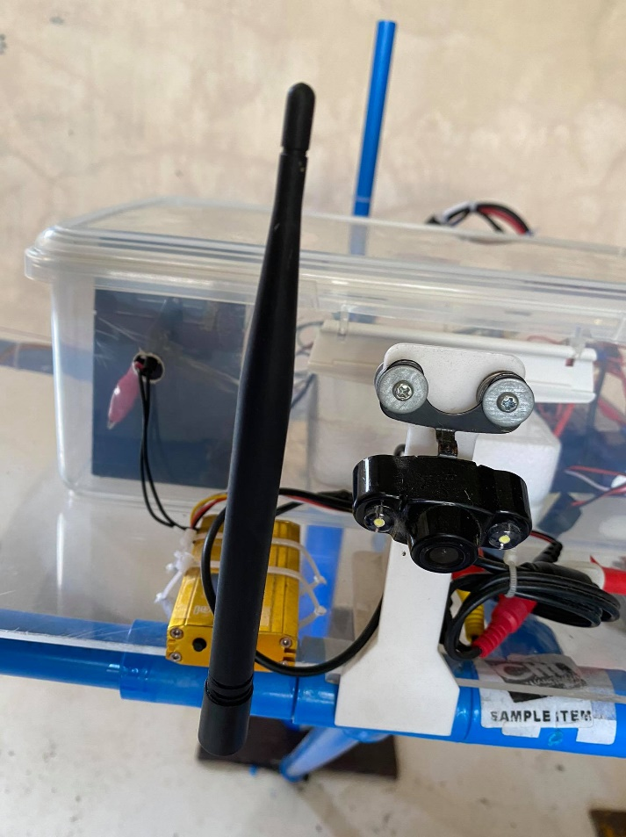

Figure 4.7 Camera with its antenna

1. Software
2. The Graphical User Interface

Connection between the camera and MATLAB program was established before starting the application with the help of imaqtool. Once the program was run, the designed user interface appeared with the live video feed from the USV. The start button was pressed in order to form connection between the RF transceiver. 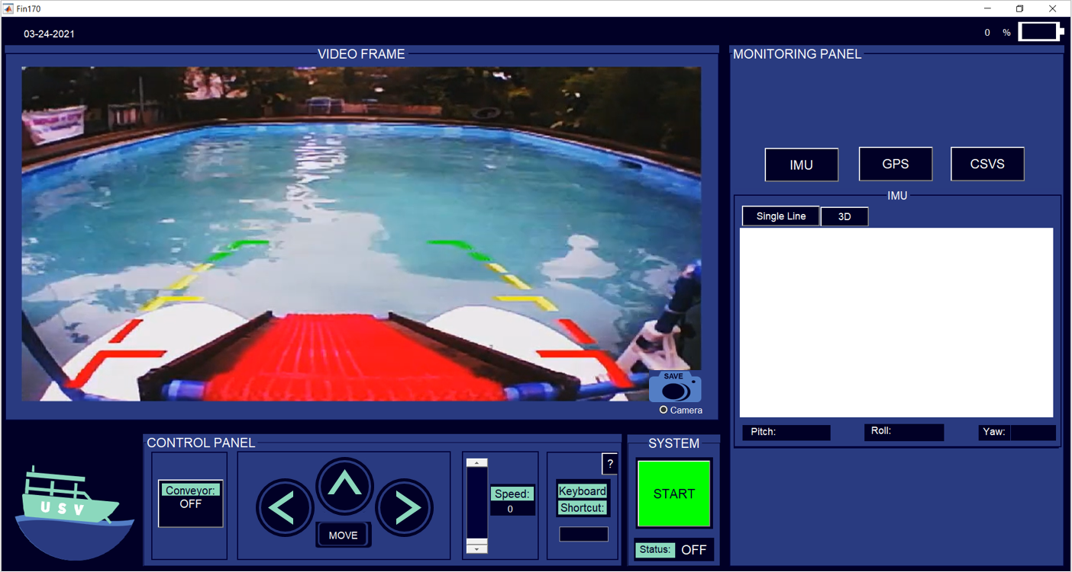

Figure 4.3 User-Interface once program is run

After the connection was set up, the control and monitoring functions of the Unmanned Surface Vehicle were fully functional. The control panel consisted of conveyor, maneuver, and propeller speed control. The monitoring panel, on the other hand, consisted of GPS mapping, IMU measurements, and voltage and current readings.

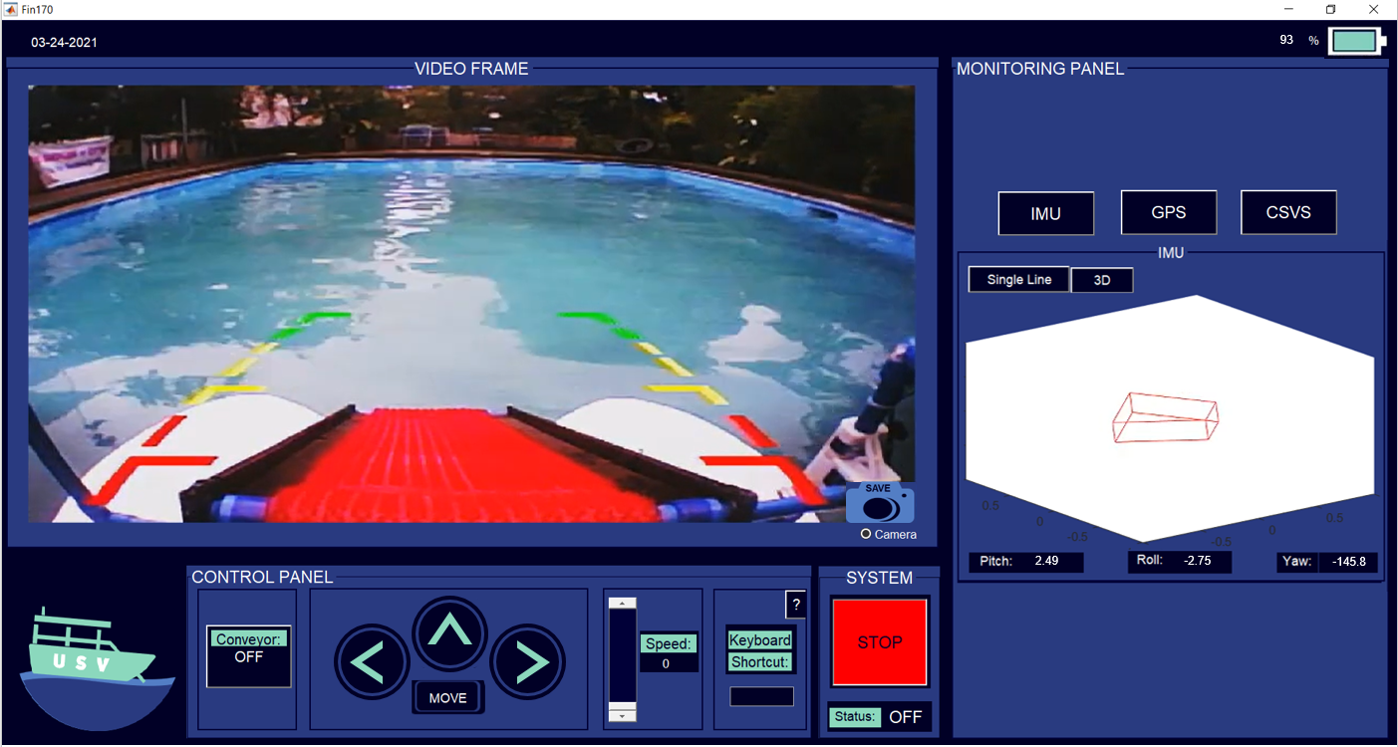

Figure 4.4 User-Interface once start button is pressed

1. Video Streaming and Capture

Wireless camera transmission was received by the user interface through a radio AV receiver. A USB to RCA cable interfaces the receiver to the computer and allowed real-time video transmission. The 640x480 pixels video input was displayed in an axis. A camera button was provided in order to capture what was on the camera axis. This captured image was automatically saved to a designated file in the computer. A radio button is also provided to allow the user to decide whether to show the video frame or hide it.

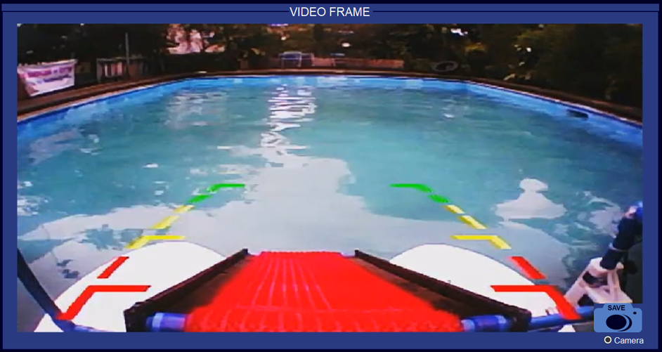

Figure 4.5 Real-time Video Transmitted

1. Control Panel

The control panel consisted of maneuver control, conveyor control, speed control and keyboard shortcut. Push buttons were used in maneuvering the surface vehicle. The maneuver panel consisted of buttons for move, stop, center, left and right movement. When the ‘move’ button was pressed the speed is automatically set to 1. The speed was later changed to desired level by using a slider. A static text displayed the propeller’s current speed. A toggle button, on the other hand, was used in order to turn the conveyor either on or off.

An edit text was also provided to enhance the USV’s accessibility by controlling it through keyboard keys. A help button was placed at the right top corner which contained information on what keys corresponded to specific USV control.

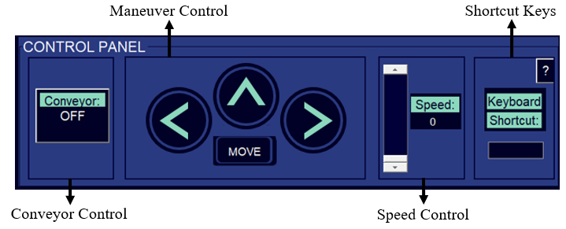

Figure 4.6 Control Panel

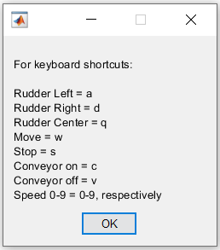

Figure 4.7 Shortcut Keys

1. Monitoring Panel

The monitoring panel consisted of three tabs, IMU tab, GPS tab, and CSVS tab, which contained the IMU measurements, GPS mapping, and voltage and current readings, respectively. When one tab was clicked the other two tabs were concealed, correspondingly. The default tab shown was the IMU measurements.

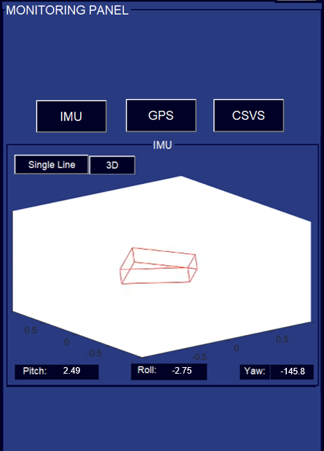

Figure 4.8 IMU measurements and graphs

The IMU measurement had two representations, single line and 3-dimension. The pitch, roll and yaw angles are updated and transmitted by the firmware every second to facilitate real-time monitoring of the surface vehicle’s orientation. When there is a change in orientation, the graph moves to the updated angles received by the software in single line or 3-dimension.

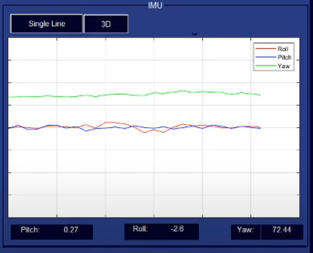

Figure 4.9 Single line representation of IMU measurements

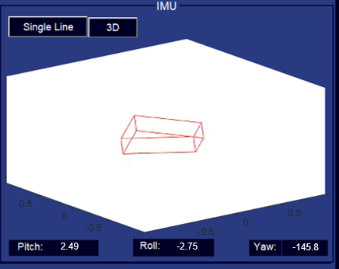

Figure 4.9 3D representation of IMU measurements

The geographic coordinates namely; longitude and latitude, from the GPS module was mapped using geoplot function from matlab. A green marker was displayed to locate the current position of the USV.

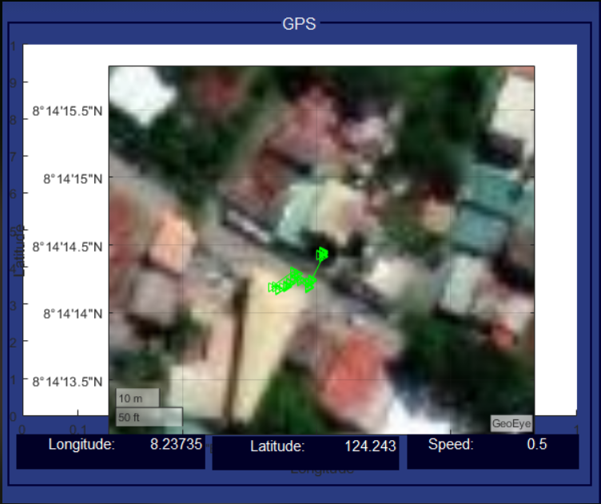

Figure 4.10 GPS Mapping

The voltage and current readings was provided. The voltage sensor showed the terminal voltage of the battery, while the current sensor showed the total current drawn by the system real time

1. Data and Battery Status Panel

On the top-left corner of the user interface the date in mm-dd-yyyy format was shown. While on the top-right corner, the battery status is provided. This is obtained from the current and voltage sensors.



Figure 4.11 Date and Battery Status

1. Firmware

The microcontroller was programmed to receive commands sent from the ground station wirelessly using the HC12 Transceiver Module. Every button from the user interface was programmed to send a specific data string in order to maneuver the USV and to operate the conveyor. Table 4.3 shows the summary of these commands.

Arduino IDE was used in programming the firmware. Servo and AX-12 libraries were used in order to control the BLDC, servo, and Dynamixel AX-12 Servo, respectively. Testing showed that motors worked well according to the commands that were received.

|  |  |  |
| --- | --- | --- |
| Data Received | Action | Code |
| “W” | Forward Propeller | propellerMotor.writeMicroseconds(vSpeed); |
| “S’ | Stop Propeller | propellerMotor.writeMicroseconds(vSpeed0); |
| “A” | Left Rudder | rudderServo.write(turnLeftRudder); |
| “D” | Right Rudder | rudderServo.write(turnRightRudder); |
| “Q” | Center Rudder | rudderServo.write(centerRudder); |
| “C” | Start Conveyor | conveyorSpeed = conveyorSpeed2;        ax12a.turn(ID, RIGHT, conveyorSpeed); |
| “V” | Stop Conveyor | conveyorSpeed = conveyorSpeed0;        ax12a.turn(ID, RIGHT, conveyorSpeed); |
| “0” | Speed 0 | vSpeed= vSpeed0; |
| “1” | Speed 1 | vSpeed= vSpeed1; |
| “2” | Speed 2 | vSpeed= vSpeed2; |
| “3” | Speed 3 | vSpeed= vSpeed3; |
| “4” | Speed 4 | vSpeed= vSpeed4; |
| “5” | Speed 5 | vSpeed= vSpeed5; |
| “6” | Speed 6 | vSpeed= vSpeed6; |
| “7” | Speed 7 | vSpeed= vSpeed7; |
| “8” | Speed 8 | vSpeed= vSpeed8; |
| “9” | Speed 9 | vSpeed= vSpeed9; |

The roll and pitch that was acquired from IMU in the arduino were compared to the roll and pitch that was acquired from the IMU of the Smartphone using the Physics Toolbox Sensor Suite Pro. The smartphone was placed beneath the Arduino Mega and were both put in a box.  The researcher tilted the box slowly in the X and Y direction. Figure below shows the data obtained from the test, the roll and pitch from the arduino and from the smartphone with a sampling rate of 0.5Hz and their graphs were almost identical to each other. Therefore, the IMU readings of the system reflect the true orientation of the boat.

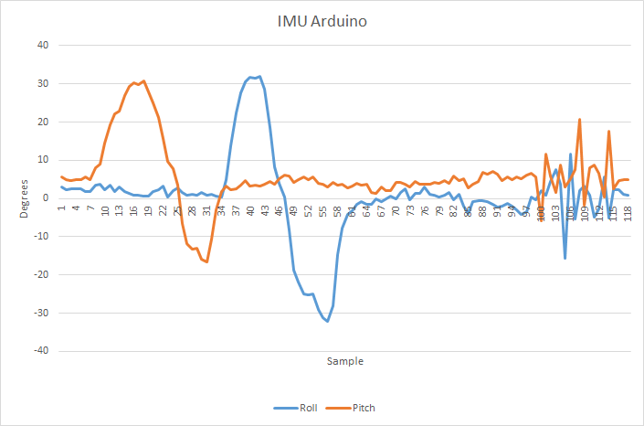

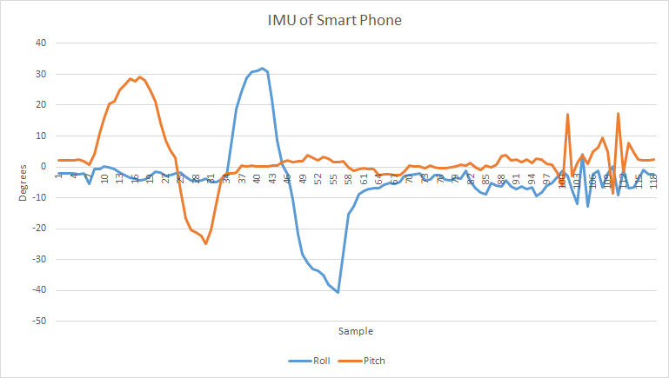

1. Testing
2. Controls

The researchers were able to test the control and monitoring of the catamaran.  The user interface that includes buttons sends commands using wireless transmission to the catamaran for the controls. This allows the user to control and move the catamaran according to the desired direction and speed.

1. Rudder

The figure below shows the rudder submerged in the water changing direction from left to right. A button is also set for the rudder to face center.

(Picture shows left)

(Picture shows right)

1. Propeller

The propeller is shown submerged in water in the figures below. The speed was also varied in the user interface using a slider. The revolution per minute or RPM of the propeller considerably decreased when submerged in water. Thus, the speed of the USV is relatively low during the testing.

(Picture shows off)

(Picture shown on)

1. Conveyor

With a belt attached to the wooden platform for the servo motor to work on, the mechanism was successful during the operation. The conveyor belt was able to collect tangible trash.

(Picture shows with trash

# CHAPTER 5

# CONCLUSION AND RECOMMENDATIONS

# REFERENCES

AlphaBoats. (n.d.). AlphaBoats Website - AlphaBoats Website. Retrieved November 20, 2019, from https://alphaboats.com/

Andrews, G. (2012). Plastics in the Ocean Affecting Human Health. Retrieved November 22, 2019, from https://serc.carleton.edu/NAGTWorkshops/health/case_studies/plastics.html

Borreguero, D., Velasco, O., & Valente, J. (2018). Experimental design of a mobile landing platform to Assist Aerial Surveys in fluvial environments. *Applied Sciences (Switzerland)*, *9*(1). https://doi.org/10.3390/app9010038

Buchmann, I. (2019). Measuring State-of-charge - Battery University. Retrieved November 22, 2019, from https://batteryuniversity.com/learn/article/how_to_measure_state_of_charge

Demetillo, A., & Taboada, E. (2019). Real-Time Water Quality Monitoring For Small Aquatic Area Using Unmanned Surface Vehicle. *Engineering, Technology & Applied Science Research*, *9*(2), 3959–3964. https://doi.org/10.5281/zenodo.2647809

Jambeck, J. R., Ji, Q., Zhang, Y.-G., Liu, D., Grossnickle, D. M., & Luo, Z.-X. (2015). Plastic waste inputs from land into the ocean. *Science*, *347*(6223), 764–768. https://doi.org/10.1126/science.1260879

Liu, Z., Zhang, Y., Yu, X., & Yuan, C. (2016). Unmanned surface vehicles: An overview of developments and challenges. *Annual Reviews in Control*, *41*, 71–93. https://doi.org/10.1016/j.arcontrol.2016.04.018

Mancini, A., Frontoni, E., & Zingaretti, P. (2015). Development of a low-cost Unmanned Surface Vehicle for digital survey. *2015 European Conference on Mobile Robots, ECMR 2015 - Proceedings*. https://doi.org/10.1109/ECMR.2015.7324189

Manley, J. E. (2016). Unmanned Maritime Vehicles, 20 years of commercial and technical evolution. *OCEANS 2016 MTS/IEEE Monterey, OCE 2016*, 1–6. https://doi.org/10.1109/OCEANS.2016.7761377

Murnane, M., & Ghazel, A. (2017). A Closer Look at State of Charge (SOC) and State of Health (SOH) Estimation Techniques for Batteries. *Analog Devices*. Retrieved from http://www.analog.com/media/en/technical-documentation/technical-articles/A-Closer-Look-at-State-Of-Charge-and-State-Health-Estimation-Techniques-....pdf

Ocean CleanUp. (2019). Rivers | The Ocean Cleanup. Retrieved November 19, 2019, from https://theoceancleanup.com/rivers/

Swan, E. (2018). Trash-eating “shark” drone takes to Dubai marina - CNN. Retrieved November 22, 2019, from https://edition.cnn.com/2018/10/30/middleeast/wasteshark-drone-dubai-marina/index.html

Vasilj, J., Stancic, I., Grujic, T., & Music, J. (2017). Design, Development and Testing of the Modular Unmanned Surface Vehicle Platform for Marine Waste Detection. *Journal of Multimedia and Information Systems*, *4*(December), 195–204. https://doi.org/10.9717/JMIS.2017.4.4.195

Walczyk, S. (2004). US20060065586A1 - Trash collection skimmer boat - Google Patents. Retrieved November 20, 2019, from https://patents.google.com/patent/US20060065586

Yuyi, Z., Yu, Z., Huanxin, L., Yunjia, L., & Liang, L. (2013). Control system design for a surface cleaning robot: Regular paper. *International Journal of Advanced Robotic Systems*, *10*, 1–5. https://doi.org/10.5772/56200